KM Hedging Plan

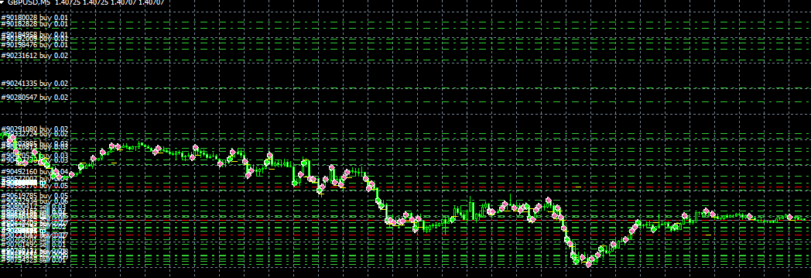

Here I will discuss my idea for hedging.

Many ideas have been discussed before. Example, when the DD for the pair hits $-100, open a reverse trade equal to the total amount of lots of previous trades.

This idea is no good because if the market begins to turn, you will be in a worse position than before. Also what people seem to forget is that, the speed at which the hedge trade would become negative if the market reversed would be much faster than the recovery of the martingale trades. So you’d still be in trouble.

The idea I will discuss is called KM Hedge Recovery (KM my initials lol).

Take a look at the above chart. GBPUSD is currently in 200 pip downtrend. I started with 0.01 lots with 1.1 exponent.

When we hit a down trend, we shouldn’t panic and try to open a buy order that will be equal to the total amount of previous trades. If you open a 1 lot buy order, this is a big risk because of what I mentioned before.

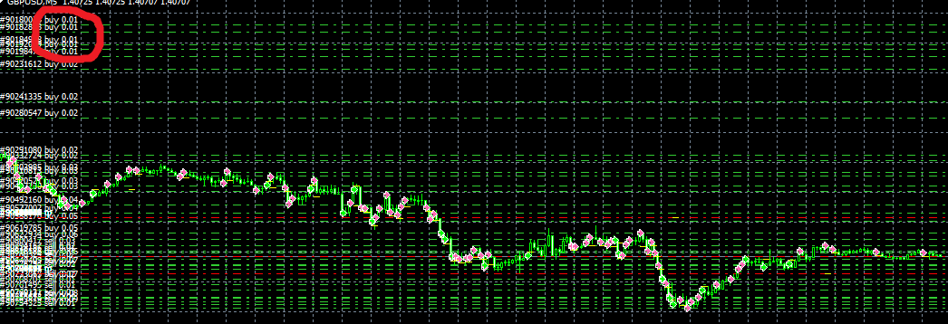

In the image above, I have circled the biggest problem for us now in the downtrend. The trades which are furthest away from the current market price. These are causing the biggest problem because they are so many pips away from the market and most difficult to recover. These trades are the ones we must target.

You may think that the latest martingale trades are the biggest problem because of their size. However, they are much closer to the current market price so more often than not, the small trades which were placed first are in fact in more individual DD and more difficult to recover. I have seen this countless times over the past 2 years of playing around with martingales.

So the idea is that when the EA triggers recovery mode, for example, $-100, the EA begins to hedge and first targets the first 5 trades. So the EA opens a hedge trade which is 3x the amount of the first 5 trades. So if the first 5 trades total 0.05, then the initial hedge trade will be 0.15. So in the above chart, we will have a 0.15 SELL trade open when the recovery mode is activated.

HOWEVER, this is the most important part, the EA MUST CONTINUE opening BUY trades as normal in the downtrend. Otherwise we will have a big gap of no trades and just be in a big loss waiting for market to turn. No matter what happens, the market will eventually turn so we need to have trades close to that turn.

The question now appears what happens if the market reverses as soon as the hedge is placed? The answer to this is that the TP of the normal martingale trades takes into account the hedge trade too. So this means the TP will be modified when the hedge trade is placed.

So whether the market continues to move down or reverse, we are in a ‘win win’ situation. It’s the best of a bad situation. Targeting the first 5 trades only, means we don’t have to have a large margin still available. This is what makes this method more feasible than opening a hedge that is equal to the size of ALL previous trades.

If we can get rid of the first 5 trades, the chart will hypothetically look like this:

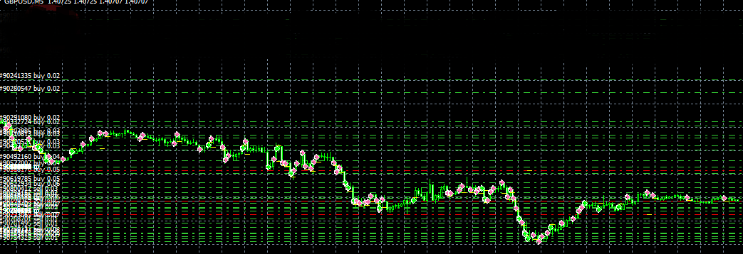

The top trades have now been successfully hedged and removed. Now there is less distance for the market to recover for us. We have removed a good amount of DD as well now.

The TP would then have to be modified again after the 5 trades and hedge have been closed.

The next step is when we have removed the first 5 trades, if the market continues in downtrend and makes a **new lower low**, we open another SELL order targeting the next 5 trades at the top of the trend. So this time the total lots of these 5 trades is 0.1, so we open 3x this amount, so we basically open a 0.3 Sell order.

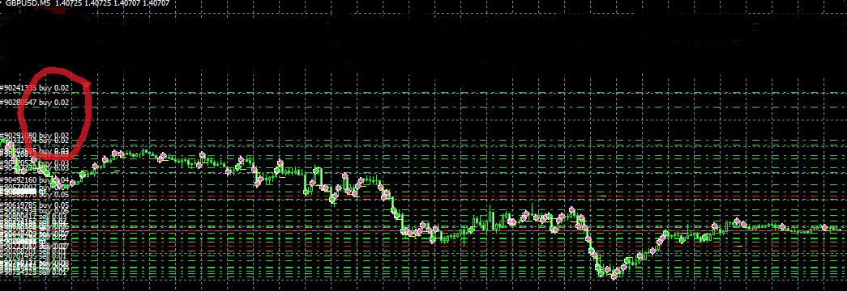

By opening hedge trades in this way, we are safe even if the market turns and begins to recover because the normal martingale trades will easily cover the hedge trade in the case of a reversal.

If the next 5 trades are hedged and removed, then once again we will be keeping the distance to recovery in check. The chart will look like this now:

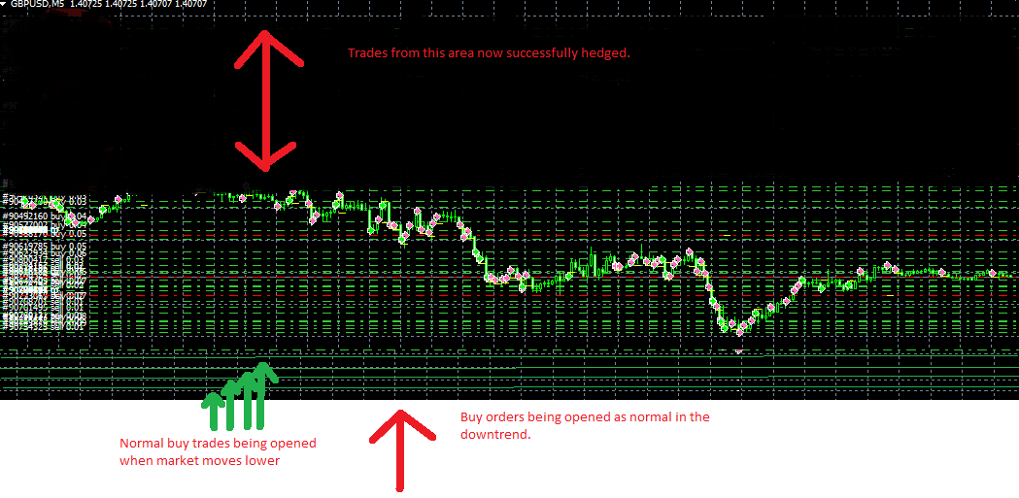

As you can see, much less distance from the earliest trade and current market price. So a full recovery is easier with less distance to reverse and recover successfully.

The next big question is when do we start hedging? From my experience with martingales and martingale type systems, if your starting lot is 0.01, then if your DD for that pair hits -$100, that’s usually a good indication you’ve ran into a trend and it’s time to get out. So for the recovery trigger, I would have it as that providing my starting lot was 0.01. The trigger value should be so that the user can change this value to their desired amount. -$100 is just my recommendation in this example.

Alternatively we could use pips as the trigger. However this would need to be based on the first trade only. Combining the negative pips of all open trades is just messy and we can’t know the best place to start the hedging. Based on the first trade, when it goes into -50 pips, this is usually a good sign you’ve hit a strong trend. But again this value should be variable so the user can choose themselves.

So this is the hedging idea

Thanks

Kasim